

Project Initialization and Planning Phase

Date | 25 September 2026
Team ID | SWTID-2026-9230
Project Name | LegalEase
Maximum Marks | 3 Marks

Define Problem Statements (Customer Problem Statement Template):
Create a problem statement to understand your customer's point of view. The Customer Problem Statement template helps you focus on what matters to create experiences people will love. A well-articulated customer problem statement allows you and your team to find the ideal solution for your customers' challenges. Throughout the process, you’ll also be able to empathize with your customers, which helps you better understand how they perceive your product or service.

Example:
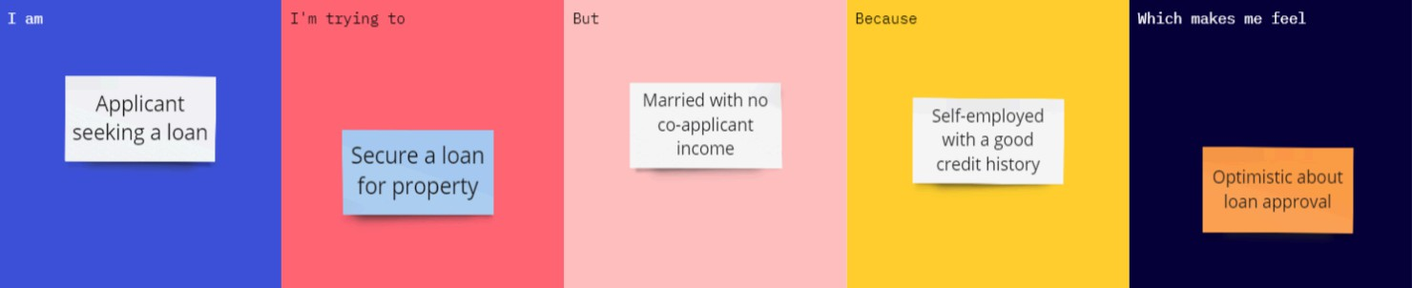

About the Project:
FitBuddy is a fitness companion app that gives users a simple, personalised 7-day workout plan based on their fitness goal, current level and the time they have each day. It removes the guesswork of what to do and when, so beginners and busy people can build a routine, stay consistent and see progress within a week.

Customer Problem Statements:

Problem Statement (PS) | I am (Customer) | I’m trying to | But | Because | Which makes me feel
PS-1 | A user who needs a legal document. | Create a structured legal draft quickly. | I do not know the correct legal structure or wording. | Legal drafting is complex and templates can be generic. | Confused and uncertain.
PS-2 | A freelancer, employee, student, or small business user. | Customize a document for my situation. | Generic templates may not match my requirements. | Different situations need different clauses and details. | Worried about missing important details.
PS-3 | A non-technical user. | Edit and download the final document. | Drafting and formatting are separate manual tasks. | Users need a simple end-to-end workflow. | Frustrated and time-pressured.

